JECRC
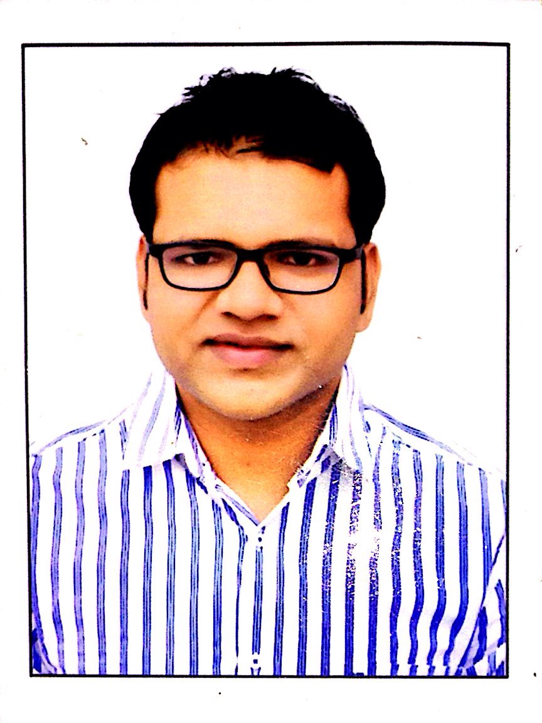
JAIPUR

INDIVIDUAL FACULTY DATA SHEET
Name of the faculty member | : | Amit Mittal
Present Designation | : | AP
Email Id: amitmittal.ce@jecrc.ac.in
Contact Details: 9461010589

I. Particulars of Educational Qualification: (only completed)

Category | Name of the Degree | Specialization | Year of Passing | Name of the College | Name of the University
UG | B.TECH | CIVIL ENGINEERING | 2012 | BMIT JAIPUR | RTU,KOTA
PG
Ph.D.

II. Academic Experience : 6 year

III. Industrial Experience :NIL

IV. Title of Ph.D. Thesis :NIL

V. Awards/Achievements : Active SDP doner

VI. Research/Specialization : NIL

VII. Course Taught : B.Tech,Diploma

VIII. Refereed International Journal Publication : IJERT

IX. International Conference Proceeding :NIL

X. Books Written : NIL

XI. M.Tech Thesis Guide : NIL
XII. PHD Thesis Guide :NIL

XIII. Professional Body Membership :

